|  |
| --- |
|  |

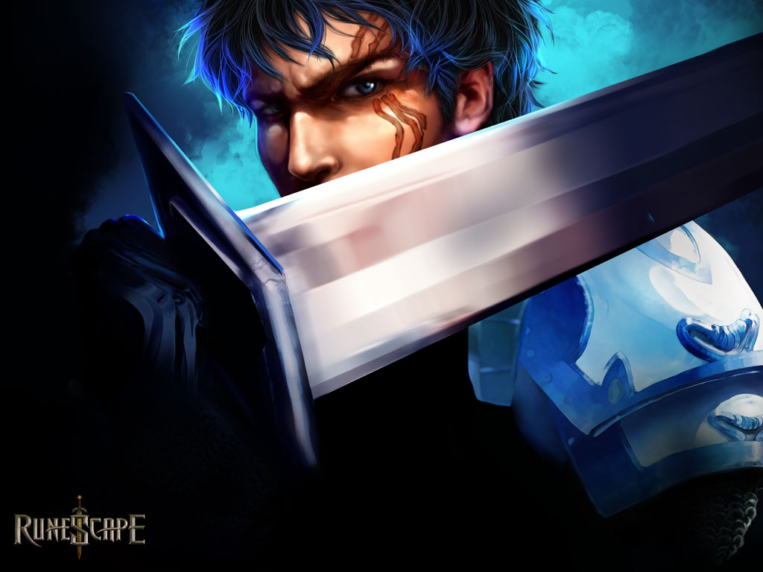

**Amina Khalique – Head Developer/ Designer/ Team Manager  
Luka Lucic – Idea Generator/ UI Designer**

|  |  |
| --- | --- |
| **DarkRaveDev** | **Rune tool 2.0 Development plan** |

# Key

**Amina Issue**

**Luka Issue**

# Current Target Market:

All 4.0 Phone Users (Tablet integration unrequired at this stage)

# Pending Problems:

Action Bar Sherlock Integration for 2.3.3 + users and Gradle being a little bitch.

# Existing Functionality that needs improvement:

## Fragment Flow

1. Smooth movement between fragments
2. Expected functionality on back button
3. Battery usage and efficiency issues need to considered.

## User Validation

1. Doesn’t work for all users. (Need to find out why)

## News

1. News bugs with video
2. News display text
3. Automatic news updates – (Controlled by settings)
4. Background classes organization (Don’t break into this unless required).

## Customer Communication

1. Need to keep better track of user complaints and suggestions.
2. Check if user can contact us easily.
3. Facebook/ Twitter/ Google + pages need to be way more active than they currently are.

## Friends

1. Deleting and adding friends

## Settings

1. Caching needs to be improved and much simpler.
2. Should be easier to understand, too crowded right now.

# Functionality that needs to be added:

## Combat Calculator

1. Integration of old school calculations (Becomes an option in settings).

## Grand Exchange

1. Add Grand Exchange offers
2. Settings functionality – Add preferences
3. Do we want automatic updating of this functionality?

## Friends

1. Access to online friends

## Activities

1. Needs to be added from scratch.

## Player Owned Ports

1. Needs to be explained and discussed
2. Ideas need to be generated.
3. How many people would actually use this thing?

## World Map

1. Map is viewable on whole. When a section is clicked it opens a map sub section.
2. Map is accessible on key points – Example towns.
3. Places of interest are also key points - Needs to be discussed.
4. In case map functionality dies – Good old backup system.

## Intuitive, Graceful UI

1. Background for heading bars
2. Background for side menu
3. Icon design – KISS
4. Sign in page background
5. Keeping familiarity up with the Current Runescape Website.

# Team Member Tasks

## Luka Lucic

1. Send Amina links for:
   1. Online friend access
   2. Grand Exchange current offers
2. Explain and discuss player owned ports
3. Discuss ideas for world map integration, and who does what?
4. Test and find out why some users validate and why others don’t?
5. Compile a collage of Runescape’s current theme ( Literally just send me a bunch of images)
   1. Backgrounds
   2. Favourite Icons
   3. Familiar Loadings Screens
   4. Sign in Page
   5. Keep to the current design (ICS)
   6. We are aiming for SIMPLICITY and PROFESSIONAL doused with copious amounts of EPIC.

|  |  |  |
| --- | --- | --- |
| Task Name and Details | Tested | Fully Done |
|  |  |  |
|  |  |  |
|  |  |  |
|  |  |  |
|  |  |  |
|  |  |  |
|  |  |  |
|  |  |  |
|  |  |  |
|  |  |  |
|  |  |  |
|  |  |  |
|  |  |  |
|  |  |  |
|  |  |  |
|  |  |  |
|  |  |  |
|  |  |  |
|  |  |  |